# Overview:

* Team Specific By Position
  + Attack
    - UCSD is one of the best teams in Big West at getting touches in opponents box and getting offensive duels
    - Need to improve offensive duel accuracy
    - Need to improve shot accuracy
    - UCSD Forwards have the most losses compared to other Big West team’s forwards
  + Midfield
    - Need to improve defensive duels accuracy
    - Best in league in offensive duels accuracy
    - Need to improve pass accuracy
    - Need to reduce losses from midfield
  + Defense
    - 5th in League in expected conceded goals minus actual conceded goals
    - Need to improve pass accuracy
    - Defense has the least involvement in the league
    - Defense has high defensive duels and aerial duels accuracy
    - Reduce losses from defense
* Player Specific By Position
  + Strikers
    - Max is in the top 14% of big west strikers for average shots on target per game but in the bottom 95% in maximizing chances (G-xG)
    - McGee is one of the most involved strikers in the big west (actions/minute) and is in the top 20% in offensive duels accuracy
    - Kai is top 11% of strikers in getting touches in the box and top 18% in winning offensive duels but struggles with shot accuracy and getting shots off
    - Val is one of the least involved strikers (Bottom 82%) but is in the top 5% for maximizing chances
  + Midfielders
    - Both Jonah and Quinn are in the top 12% for most average losses per game
    - Both Jonah and Quinn are in the top 17% of midfielders in having passes breakthrough into the attacking third
    - Jonah is around the bottom 60% in offensive and defensive duels for midfielders
    - Both Jonah and Quinn tend to be more involved than other midfielders in the Big West
    - Quinn is in the top 12% of midfielders in winning offensive duels and in the top 12% in passing forward more often
  + Defenders
    - Outside backs Carter and James are both in the bottom 70% of defenders for pass accuracy
    - Our defenders are less involved than other defenders in the big west
    - All of our defenders are good in aerial duels and are in the top 35%
    - Adam is in the bottom 75% of defenders in defensive duels accuracy
    - Adam is in the top 2% of defenders in long pass accuracy
    - Both of our center backs are in the top 11% of defenders in playing long balls a majority of the time.

# Teams

## Attack

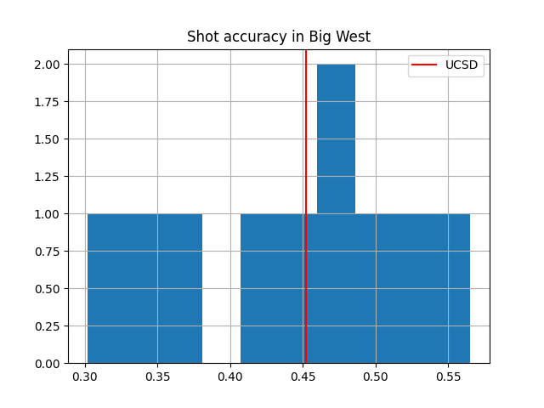

### Attack Notes:

* Forwards have the most touches in opponents penalty area per game average in Big West
* Forwards have the most offensive duels average per match in Big West
* Offensive duel accuracy of forwards is average
* Third most shots on target average per game in Big West
* 6th most shot accuracy per game in Big West
* UCSD Forwards are the second most involved attacking group in Big West
* UCSD Forwards have the most losses in Big West

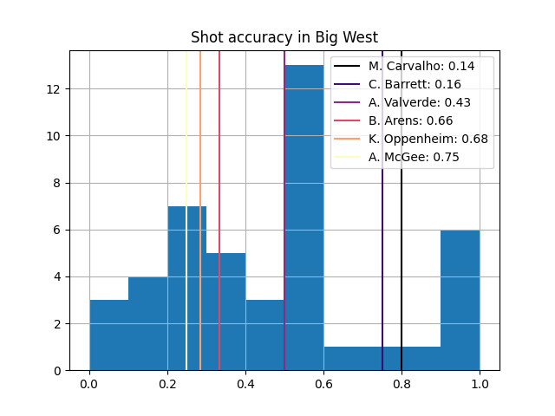

## Midfield

## 

### Midfield Notes:

* UCSD Midfield 5th in pass accuracy
* UCSD Midfield 2nd most involved midfield in Big West
* Defensive duels UCSD is 6th
* Offensive duels UCSD is 1st

## Defense

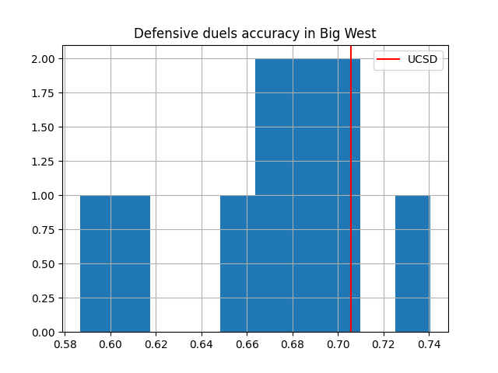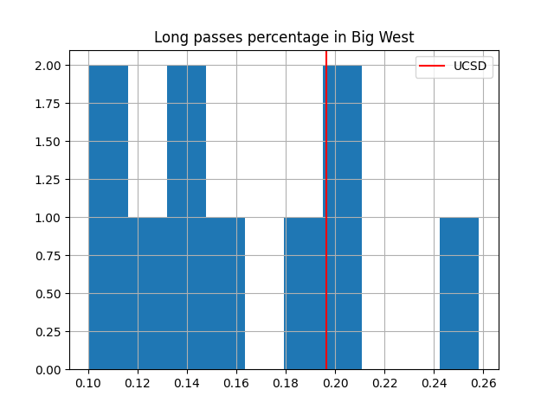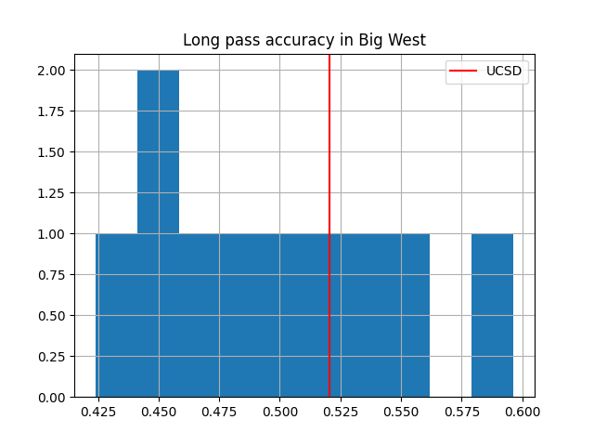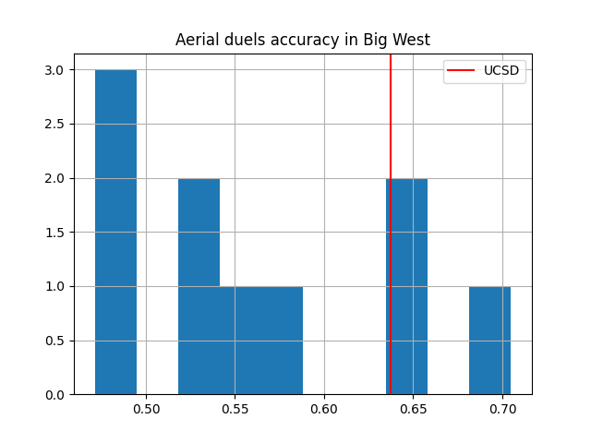

### 

### 

### Defense Notes:

* Defense has one of the lowest pass accuracy in the league
* Defense is the least involved defense in the league
* Defense has the 3rd highest defensive duels accuracy and aerial duels accuracy in league
* Defense goes long the 3rd most in the league
* UCSD is 4th in long pass accuracy
* UCSD defense has 5th most losses in league

# Player Specific

## Attacking Players

### 

### Attacking Player Notes:

* Max and Kai are both in the top 11% of attackers at getting into the box
* Max and McGee both are high in amount of Offensive duels
  + While Kai and McGee are both in top 20% of big west strikers at successfully taking on opponents
* All of our strikers except for Max (14%) are in the bottom 50% in shots on target
  + Max and Cole are both in top (16%) in shot on target percentage
* McGee is in the top 2% of strikers in getting touches per minute
* Max is in the bottom 98% of strikers for having the least amount of losses
* Val and Kai are in the top 7% of strikers in maximizing chances while Max is in the bottom 95%

## 

## Midfield Players

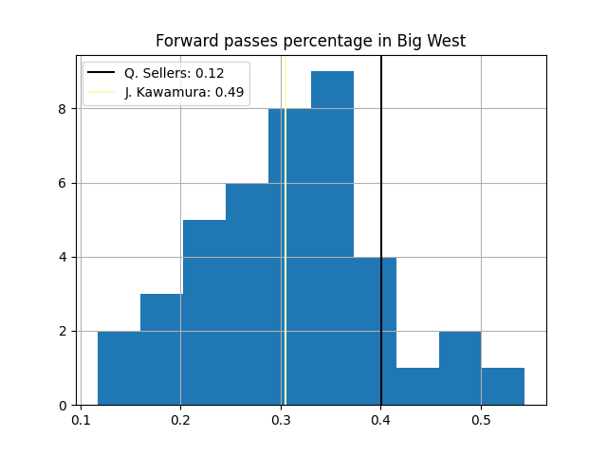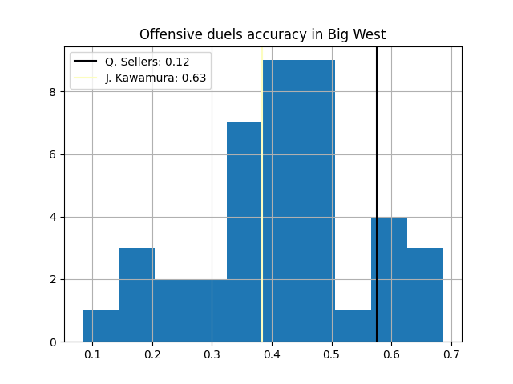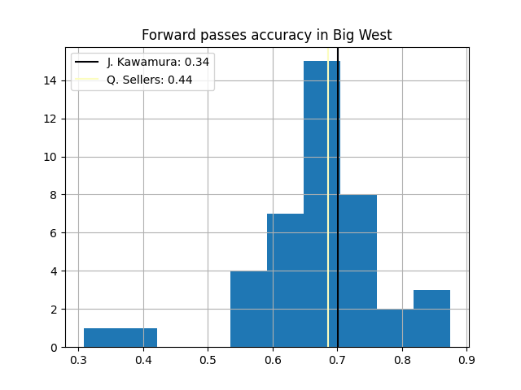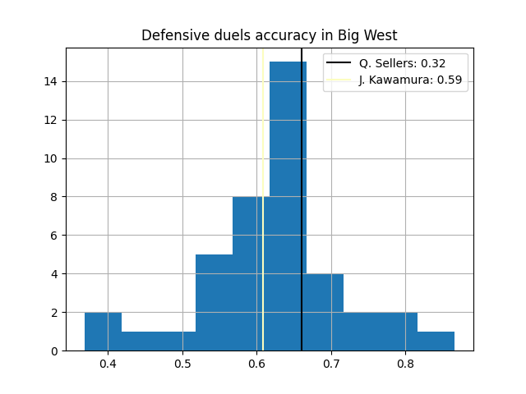

### Midfield Player Notes:

* Both pass accuracy and forward pass accuracy is around average for midfielders in the Big West
* Both Jonah and Quinn tend to be more involved than other midfielders in the Big West
* Quinn is in the top 12% in passing forward most of the time while Jonah is in the top 50%
* Quinn is in the top 12% in winning offensive duels while Jonah is in the bottom 63%
* Defensive duels accuracy Jonah is in the bottom 59% of midfielders
* Both Jonah and Quinn are in the top 17% of midfielders in having passes breakthrough into the attacking third
* Both Jonah and Quinn are in the top 12% for most average losses per game

## Defending Players

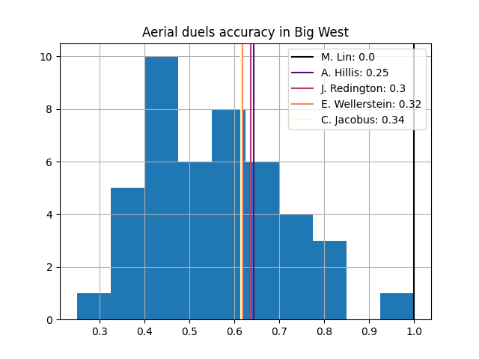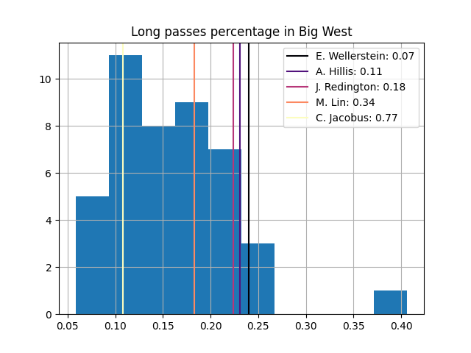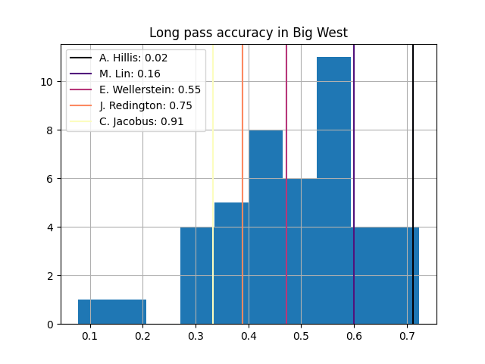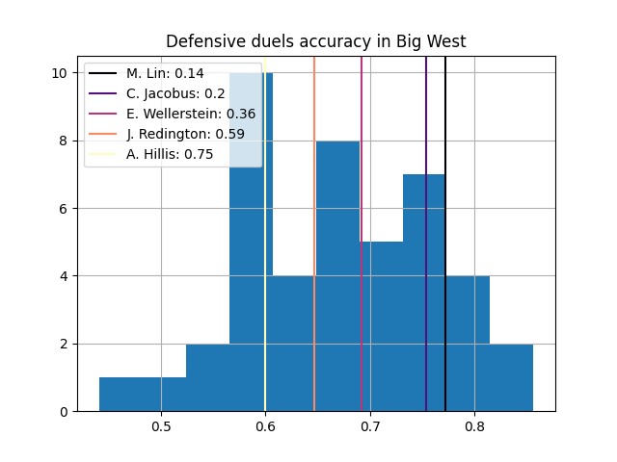

### Defending Players Notes:

* Outside backs Carter and James are both in the bottom 70% of defenders for pass accuracy
* Our defenders are less involved than other defenders in the big west
* All of our defenders are good in aerial duels and are in the top 35%
* Adam is in the bottom 75% of defenders in defensive duels accuracy
* Adam is in the top 2% of defenders in long pass accuracy
* Both of our center backs are in the top 11% of defenders in playing long balls a majority of the time.